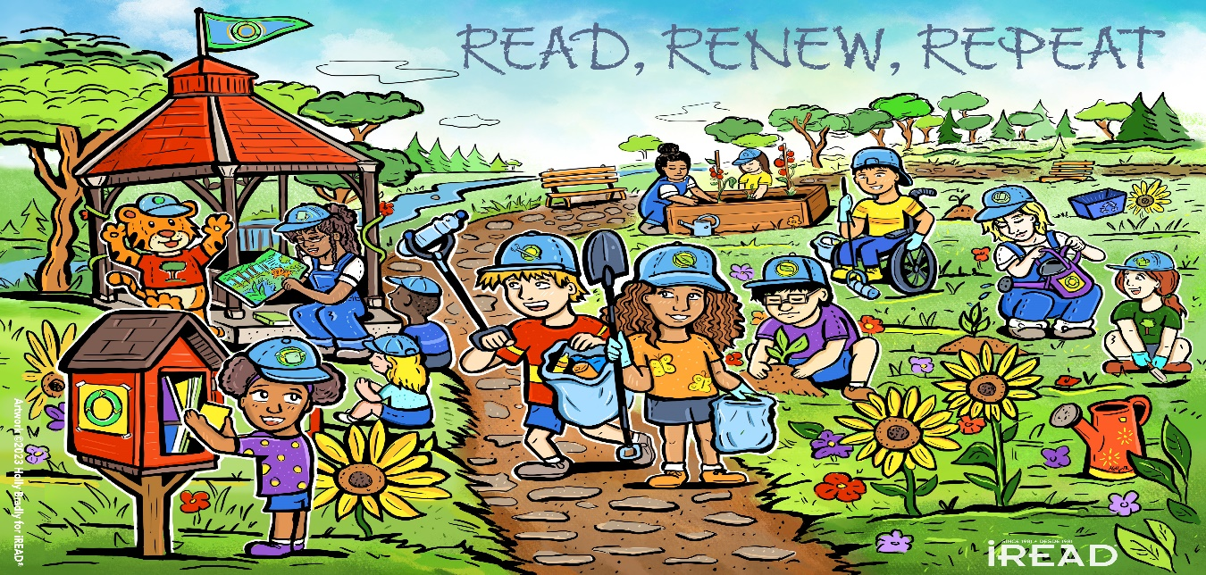

Summer Reading Program 2024 Read, Renew, Repeat
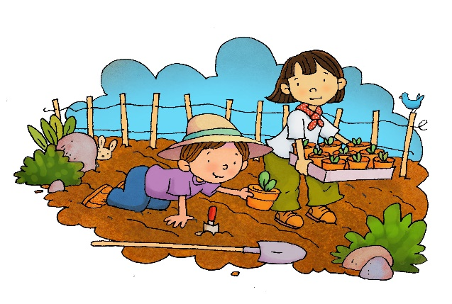
Come join us at Ricker Library this summer for five Tuesdays of crafts, games, and lots of fun. We will be learning about various things like renewable resources, endangered species, and our environment. Summer reading will be starting every Tuesday July 9th to August 6th. The program starts at 10:00.
Preschool: 7/9 Planting with Soil 7/16 Recyclable Art 7/23 Endangered Animal Scavenger Hunt 7/30 Recyclable Polar Bear
School age:
Special Events:
July 19th Mammals of Maine, a Seals Journey
August 6th Sparks Ark
7/9 Polar Bears 7/16 Elephants 7/23 Graphic Novel 7/30 Mazes

Please come in to register at the library after June 10th.

